FINAL INTERNATIONAL UNIVERSITY
FACULTY OF EDUCATIONAL SCIENCES
ELT PROGRAM
TEACHING PRACTICE HANDBOOK
ELTP401 and ELTP402

TEACHING PRACTICE
Introduction
This course is scheduled for the first and the second terms of senior classes to enable teacher candidates to be better prepared for the teaching profession, to demonstrate the competence to use the knowledge, skills, attitudes and habits about the general culture, specific field education and teaching profession they learned during their education in real life environment.
In order to achieve these goals, it is necessary to have a close cooperation between the Faculty of Education and the institutions affiliated to the Ministry of National Education. With an efficient cooperation environment, it will be ensured to carry out planning, implementation and assessment processes of education-training within the framework of certain principles and to establish a high level of standard.
This cooperation will also ensure the exchange of knowledge and experience between the faculty where theoretical studies are carried out and schools where these are actually practiced. Thus, the two institutions will enable to achieve theory and practice harmony by influencing each other.
The legal basis of practice at schools is based on National Education Basic Law, the law on the organization and duties of Ministry of Education, and the regulations and the directives issued on the basis of relevant provisions of the Law of Higher education.
Final International University has protocols with The Ministry of Education in TRNC and Final Okulları in Turkey to carry out Teaching Practice 1 and 2 Courses; this enables our students to attend these courses in both countries when it is necessary and they volunteer to do so during vacation.

Table of Contents

PART I: FOUNDATIONS OF FACULTY SCHOOL COLLABORATION
A- Purpose and Scope of Practice at Schools
B- Definitions
C- Practicum School
D- Principles of Practicum
E- Duties and responsibilities

PART II: IMPLEMENTATION OF TEACHING PRACTICE 1
- Scope of the course and syllabus
B- Teaching practice activities and report writing principles
C- Evaluation of Teaching Practice Course

PART III: IMPLEMENTATION OF TEACHING PRACTICE 2
- Scope of the course and syllabus
B- Teaching practice activities and report writing principles
C- Evaluation of Teaching Practice Course

Part IV: Micro-teaching

Appendices
Lesson Plan Formats
Lesson Planning Checklist
Letters to be written to the principles of practicum schools
Attendance Form signed by the practicum school teacher and student
Teaching practice schedule signed by practicum school teachers
Final Grading signed by Practicum School Principal and Teachers
Teaching Practice Evaluation Form
Peer Observation Form
Practicum Student’s Diary

PART I: FOUNDATIONS OF FACULTY SCHOOL COLLABORATION
- Purpose and Scope of Practice at Schools
The aim of Teaching Practice 1 and 2 Courses is to enable teacher candidates to be better prepared for the teaching profession, to acquire the competence to use the knowledge, skills, attitudes and habits about the general culture, specific field education and teaching profession they learned during their education in real life environment.
In order to achieve these goals, it is necessary to have a close cooperation between the Faculty of Educational Sciences and the institutions affiliated to the Ministry of National Education. With an efficient cooperation environment, it will be ensured to carry out planning, implementation and assessment processes of education- training within the framework of certain principles and to establish a high level of standard.
In addition, this cooperation will ensure the exchange of knowledge and experience between the faculty where theoretical studies are carried out and the schools where these are actually practiced. Thus, the two institutions will enable to achieve theory and practice harmony by influencing each other.
The legal basis of practice at schools is based on National Education Basic Law, the law on the organization and duties of Ministry of Education, and the regulations and the directives issued on the basis of relevant provisions of the Law of Higher education.

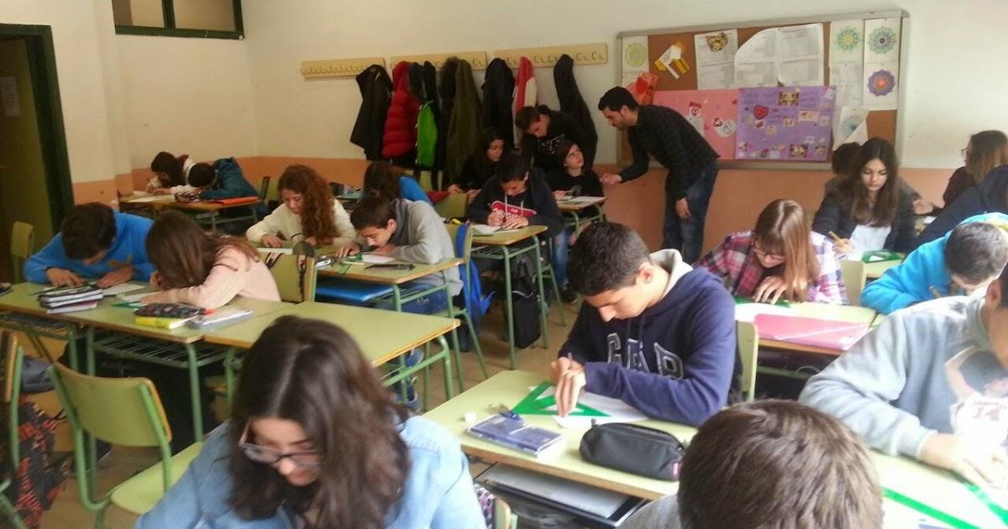
- Definitions
Teacher candidate: A student of higher education institution who continues to attend teaching programs and performs teaching experience in the school environment at the level and setting in which s/he will be a teacher.
Teaching Practice I: This is a course in the curriculum of the faculty to give teacher candidates the opportunity to get to know the school organization and management and daily life in schools, to examine the educational environments, to participate in extra-curricular activities, to observe experienced teachers at work, to work with students individually or in small groups, to gain short-term experience, to help them understand and internalize teaching profession accurately.
Teaching Practice II: This is a course that provides teacher candidates with teaching skills in the field and at the teaching level in which they will be a teacher, enables them to teach a specific course or courses in a planned way, and gives them the opportunity to discuss and evaluate practicum activities.
Faculty Practicum Coordinator: The vice dean who is responsible for teaching and training and who ensures that Teaching Practice observations, and teaching practice of teacher candidates at schools are carried out according to determined principles.
Department / Program Practicum Coordinator: The lecturer at the teacher candidate’s department / program who plans and carries out the teaching practices.
Faculty Practicum Instructor: The lecturer at the faculty who plans, carries out and evaluates the practicum activities of the teaching candidate.
Practicum Coordinator of National Education Directorate: The director of National Education or vice director who ensures that the practicum activities of the teacher candidates in schools are planned and carried out according to the principles planned by faculty and school coordinators.
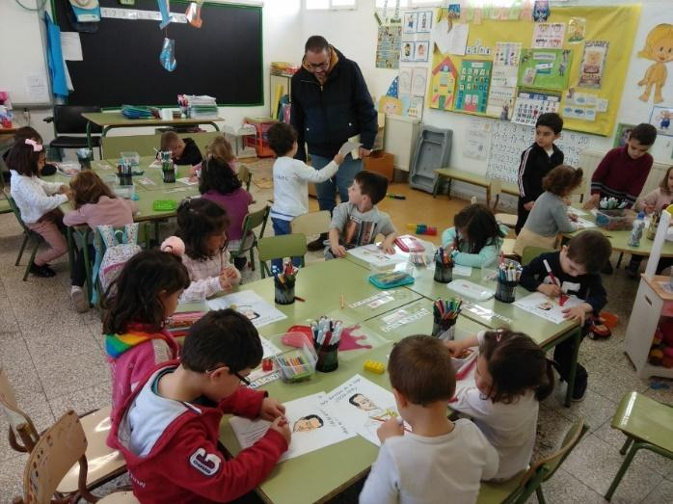
School Practicum Coordinator: The school director or vice director who ensures that practicum activities in school are carried out according to the determined principles.

School Practicum Teacher: The classroom teacher or the course teacher who acts as an advisor for the teacher candidate in gaining the behavior required by the teaching profession.
- Practicum School
Teaching Practice 1 and 2 are carried out in the province or district where the faculty is located. Classroom teachers and course teachers who will work in primary schools can do some of their practices in village schools if possible.
It is desirable to have more practicum schools than available today for teacher candidates who take Teaching Practice 1 and 2 Courses. Ideally, schools should be asked to accept as many teacher candidates as the teachers can manage; schools shouldn’t be overburdened with more students than they can deal with. It should be kept in mind that teacher candidates can work in pairs, observe each other, help and support each other during their Teaching Practice 1 and 2.
In principle, teacher candidates should have practicum activities in whichever school they are trained to work as a teacher and should teach all the courses they will be responsible for in their actual teaching. For instance, teacher candidates in Classroom Teaching Programs should be given the opportunity to teach the additional courses for 6-8 grades. Over time, teacher candidates should find opportunities to practice in schools that have different structures, schools that are located in rural and urban areas, in normal and unified classes in large and small settlements.
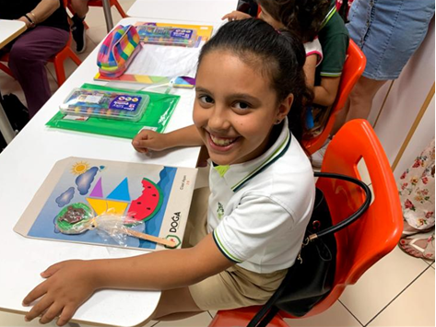
In order to become a practicum school, a school should:
- Agree to provide professional and personal support to the teacher candidates;
- Have a suitable environment and facilities for the training of the teacher candidates;
- Have the resources to provide teaching experience relevant to target age groups and courses;
- Have teaching staff experienced in working with the teacher candidates and interested in their needs;
- Be in a convenient place for the transportation of the teacher candidates;
- Have management that will work in full cooperation with the relevant units of the university to organize, monitor and evaluate the practicum activities of the teacher candidates.

- Principles of Practicum
Practicum is planned, programmed and carried out in line with the following principles:
- Principle of practice in school environment: Practicum activities are carried out at the education level where teacher candidates will be working, in a real interaction environment relevant to their fields, in formal, private, boarding, day-time, dormitory, pre-school, primary, general and vocational secondary education; special education, apprenticeship and non-formal institutions.
- Principle of Active Participation: It is essential for the teacher candidates to participate effectively in teaching-learning and communication processes. Therefore, each teacher candidate is asked to perform a series of activities in person in practicum. It is ensured that the teacher candidates carry out these incrementally, consistently and with increasing responsibility. Teacher candidates carry out the activities of practicum preparation, observation in practicum school, participation in the duties of school practicum teacher, participation in teaching-training, management and extra-curricular activities, and the evaluation of practicum activities.
- Principle of extending practicum process over a wide period of time: The program of practicum consists of a comprehensive set of processes such as planning, review, research, participation, analysis, monitoring, evaluation and development. Each of these processes consists of preparation, practice, evaluation, and development stages. In order to acquire these teaching behavior through these processes at the required level, teacher candidates need much more time and effort than they will actually practice. Therefore, practicum activities are placed in the program at least for one semester in order to give the teacher candidates gradually increasing responsibility and practice competence.
- Principle of co-evaluation: As the practicum instructor and the school practicum teacher plan and carry out practicum activities together, the performance of teacher candidate is evaluated by them respectively. The achievement of the teacher candidate in teaching practice is determined as a grade by combining the evaluations made by the practicum instructor and the school practicum teacher in accordance with the “Education and Examination Regulation”. Practicum instructor submits the grades to the faculty management.
- Principle of Scope and Diversity: Teaching profession consists of a wide range of activities such as preparation, presentation, classroom management, workshop and laboratory management, student evaluation, participation in managerial and educational activities. In addition, teachers in various parts of the country work at schools with different structures and conditions, such as boarding, daily schools and schools with dormitories, city and village schools and normal and unified classes. For this reason, practicum is planned and carried out in such a way and variety to cover all duties and responsibilities required by the teaching profession.
- Principle of continuous development of the practicum process and the practicum staff: According to the results obtained from practicum studies, practicum process and in parallel with this, the competencies of the staff participating in the practice are constantly improved.
- Principle of the practice of practicum on-site and with supervision: The expected benefit from practicum can only be achieved with the efforts of practicum instructor to closely monitor, guide, correct the mistakes, deal with the deficiencies and evaluate the activities done by the teacher candidate during the practicum. For this reason, practicum is carried out in the schools and institutions in the province district where the faculty is located.
- Duties and responsibilities
The success of the practicum is possible only if the staff members at all levels fulfill their responsibilities properly. The list of duties and responsibilities is given below:
- Duties and responsibilities of faculty practicum coordinator:
- Determines the practicum schools in cooperation with department practicum coordinator and the practicum coordinator of National Education Directorate, and ensures the distribution of teacher candidates to these schools;
- Monitors and supervises the practicum activities on behalf of the faculty;
- Evaluates the practicum studies and takes the necessary measures to improve them.

- Duties and responsibilities of department practicum coordinator:
- Provides coordination and cooperation between the department practicum instructors on practicum activities;
- Prepares the lists of faculty practicum instructors and the students that are given to the responsibility of these faculty practicum instructors, and submits them to the faculty practicum coordinator;
- Helps the faculty practicum coordinator in choosing practicum schools.

- Duties and responsibilities of faculty practicum instructors:
- Prepares teacher candidates for practicum activities effectively;
- Plans the activities within the scope of practicum together with school practicum coordinator and school practicum teacher;
- Informs the schools in advance about the teacher candidates and the tasks they will fulfill.
- Cooperates with the schools where practicum is carried out in order to facilitate teacher candidate’s studies in schools, and regularly monitors and supervises these practices together with the school teacher;
- Advises the teacher candidates at every stage when needed and discusses their progress with them, reviews their achievements and sets goals for their development;
- Maintains contact with school practicum teachers to discuss the improvement of teacher candidates during the practicum and their assessment;
- Ensures that sufficient number of copies of observation forms, etc. are supplied to school practicum teachers;
- Evaluates the studies of the teacher candidates at the end of the practicum together with the school practicum teacher and submits the results to the faculty management as a grade.

- Duties and responsibilities of practicum coordinator of National Education Directorate:
- Determines the practicum schools and their quota in corporation with the faculty and school practicum coordinators;
- Supervises and evaluates practicum activities and takes necessary measures so that they are carried out effectively;

- Duties and responsibilities of school practicum coordinators:
- Ensures coordination and cooperation between the National Education Directorate, the school administration and the faculty;
- Plans, monitors and evaluates the practices of teacher candidates together with the practicum instructor and the school practicum teacher and takes the necessary measures.

- Duties and responsibilities of school practicum teacher:
- Plans the activities within the scope of practicum studies of the teacher candidate in cooperation with practicum instructor and school practicum coordinator;
- Ensures that the activities required by the program are carried out, guides the teacher candidate, monitors and supervises the activities;
- Evaluates the practices of the teacher candidate at the end of the practicum and delivers them to the school practicum coordinator.

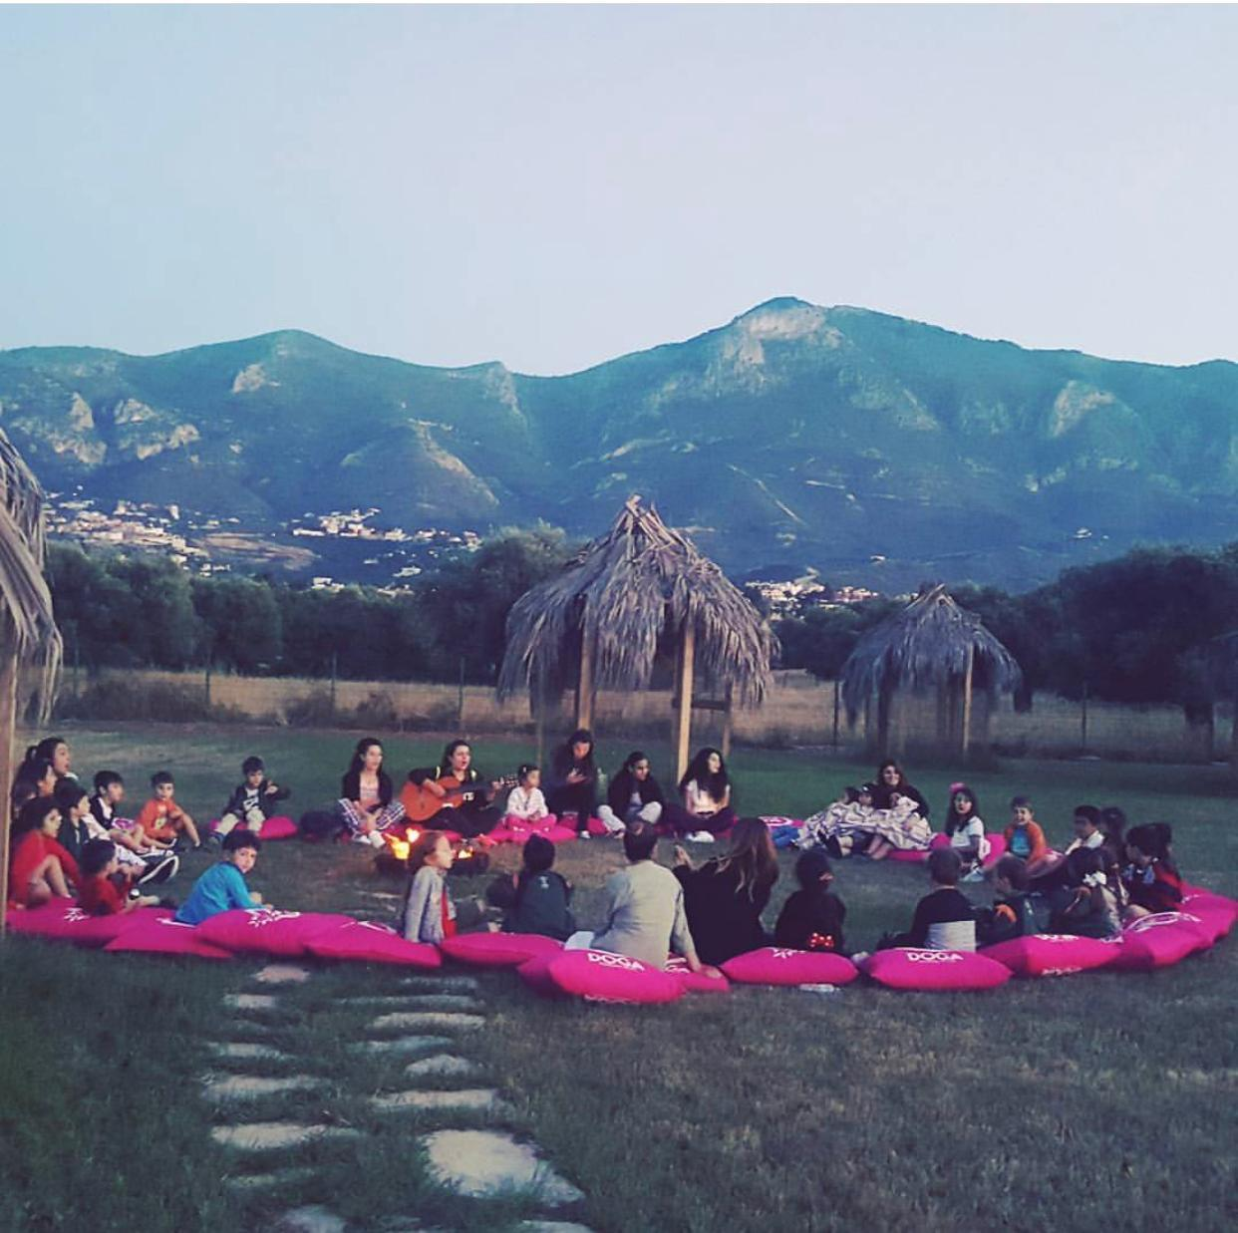
Faculty practicum instructors give explanations to the teachers regarding the duties and responsibilities of the faculty, the practicum school and the teacher candidates as collaborators in this cooperation. Teachers’ opinions are taken on what needs to be done while sending them to schools in order to get the optimum results from practicum practices. There should be a consensus between the faculty practicum instructors and teachers especially on the monitoring teacher candidates and the evaluation of their progress. Teachers who have little experience in teacher training may need guidance on filling out the observation forms, points to be considered in the lessons given by teacher candidates and how to give effective feedback to the teacher candidates.
It is the responsibility of education faculties to train teachers in schools for practicum practices to be able to benefit from their contributions and to make this task as satisfying as possible for them.
- Duties and responsibilities of teacher candidates:
- Works in a planned and regular way to fulfill the requirements of the practicum program;
- Acts in a planned way in cooperation with the faculty practicum instructor, school administration, school practicum teacher and the other teacher candidates;
- Has a close contact with the school practicum teacher and follows the points stated by her meticulously; it is an absolute necessity to comply with the rules set by the school.
- Submits to the faculty practicum instructor the file containing their work within the scope of practicum practices, all the discussions on them and the evaluations;
- Contributes to the progress of the students given to their responsibility requested by the school, and endeavors to ensure that they gain interesting and valuable learning experiences.

PART II: IMPLEMENTATION OF TEACHING PRACTICE
- Scope of the course and course syllabus
It is essential for teacher candidates to do practicum with teachers and students while preparing for the teaching profession. The first part of these courses for this purpose consists of planned observations and activities that aim to introduce to the teacher candidate a number of tasks teaching profession involves. The Teaching Practice I Course consists of 2 theoretical hours and 6 practice hours, amounting to 5 credits and 10 ECTS. The Teaching Practice II Course consists of 2 theoretical hours and 6 practice hours, amounting to 5 credits and 15 ECTS. The theoretical part is carried out at the university under the supervision of course instructor, while the practice lessons are carried out at the practicum school.
The aim of the course is to create professional competencies that the teacher candidates will need in their future careers as teachers through their experience at practicum schools and real classroom environment; to assist teacher candidates in developing a variety of teaching techniques that they can adapt to the age, ability, and special needs of students, to help teacher candidates be good teachers who have the understanding and attitude that can contribute to creating an effective school environment.
Practicum courses aim at making observations about school life, reflecting on these observations, and gaining experience in teaching skills. The tasks and activities the teacher candidates do in this course should provide them with the opportunity to observe experienced teachers at work, to work with the students individually or in small groups and to gain short-term teaching experience albeit with limited responsibilities. During practicum period, a certain number of activities will be carried out and the files containing the reports about these activities will be delivered to the faculty practicum instructor within the week they belong to on a specified day and time. At the end of the term, these assignments will be gathered in a file and used to determine the student’s grade.
The following information should be written on the cover page of each report:
Name and Surname of Teacher Candidate:
Student Number:
Department:
Program:
Name of the Practicum School:
School Practicum Teacher:
Faculty Practicum Instructor:
Title of the Activity:
Submission Date of the Report:

Upon completion of Teaching Practice course, teacher candidates should have acquired the following qualifications: getting to know the school organization and teaching profession with a systematic approach; gaining the necessary professional competencies through well-organized teaching experiences to carry out teaching-learning activities within the scope of the curriculum; having experience about individual differences between the students in terms of learning and development; collaborating with teachers in practicum school and developing the personal skills necessary to work effectively in a school, being knowledgeable about the school organization, management, the daily work in the school and the tools - facilities and resources in the schools.
To the attention of teacher candidates
While performing tasks and activities you are advised to focus on one aspect of teaching at a time and reflect on the specific teaching experience. You should learn as much as you can by observing the practicum teachers and gaining information regarding their teaching practices. Later, you should develop your teaching skills by combining what you have learned with your knowledge and experience. When you successfully complete these activities, you will be ready to undertake further professional development towards becoming a teacher.
When you observe a teacher, you should act like a professional and prepare and make arrangements in accordance with the rules and with utmost care. Before your visits to schools, you should go through all the tasks in the course and try to understand how these tasks are arranged in a sequential order to improve your teaching skills. You are expected to make the necessary preparation before each task or activity; you should also meet the teachers you intend to observe beforehand and inform them of your to-do tasks and activities; You are also required to share your observation checklists and notes with the respective teacher after your observation. If you are going to teach a class for a short time or one class hour, make sure to prepare well in advance. You have to ensure that the teacher knows what you are going to do and agrees with what and how you are going to teach the lesson. Thus, show the teacher your lesson plan and make sure to include their feedback in your lesson. It is essential to meet the teacher before your teaching practice since this can significantly impact your teaching and contents of your lesson.
During the course period, you are expected to be present at school on an assigned day each week. Meanwhile, you are expected to become familiar with students in the class. As you work with them, your confidence will also increase. Additionally, as your practicum continues, you will most likely become interested in all aspects of the teaching practice in the classroom while trying to handle the arising issues to the best of your abilities.
You may collaborate with another teacher candidate during your practicum period. If this is the case, you should try to help and support each other, benefit from each other as observers and evaluators, and pool your resources together to conduct team teaching.
Your Teaching Practice portfolio is of utmost importance; thus, you are required to keep a record of your activities. You should neatly record and file information regarding your answers to the questions, the reports requested from you, the evaluations and the forms you filled in. You should also organize your information in your portfolio in a way that clearly shows what you have done during the course, give information to the faculty practicum instructor and the school practicum teacher who is guiding you, and relate it appropriately to the activities and tasks you do throughout the course. By comparing the activities in your portfolio with the assignments and tasks that you complete in your faculty courses on the same subjects; you should combine your theoretical knowledge gained at the university with the practical skills and activities in your Teaching Practice 1.
• Always make sure you go through your preparations for the tasks you are going to perform during the semester with the school principal and the classroom teacher(s) you are going to work with for 14 weeks in both academic semesters.
• On your first day at school, meet the practicum teacher and the school principal to discuss and finalize your study plan for the remaining weeks.
• Make an appointment for an interview with the school practicum teacher(s) who will monitor you closely in your school activities. In the meeting, explain the activities that your faculty practicum teacher expects you to do during the semester. Ask them to help you arrange these activities in an appropriate order.
• Learn how to contact your school practicum teacher when needed on the days you are at schools.
• Pay utmost importance to your teaching portfolio from the beginning of the practicum period. Make sure that your dossier is organized and that your notes for each event are complete and in place.
• Make sure that your notes and evaluations about the course are in your portfolio.
• Discuss your progress and the activities you complete during the semester with the faculty practicum instructor and the school practicum teacher you work with.
• Reflect on your completed activities and reports and include them in your portfolio; do not forget to especially note your strengths and weaknesses.

Course syllabus: Even though it is advised not to have a strictly set syllabus for this course as it needs to be designed according to the needs of the teacher candidates and schools, a flexible syllabus contains some of the following items as needed:
Weeks | Activities
Week 1 | Introduction to the course  Code of Conduct schedule
Week 2 | Semester Schedule  Use of classroom language
Week 3 | A day of a teacher at school
Week 4 | A day of a student at school
Week 5 | Planning the lesson and sequencing the activities
Week 6 | Use of teaching methods
Week 7 | Lesson and classroom management
Week 8 | Reports and presentations
Week 9 | Making use of textbooks, preparing worksheets and other materials
Week 10 | School management, facilities and constraints
Week 11 | Micro-Teaching
Week 12 | Micro-Teaching
Week 13 | Micro-Teaching
Week 14 | Micro-Teaching
Week 15 | Portfolio submission and Course Evaluation
- Teaching practice activities and report writing principles
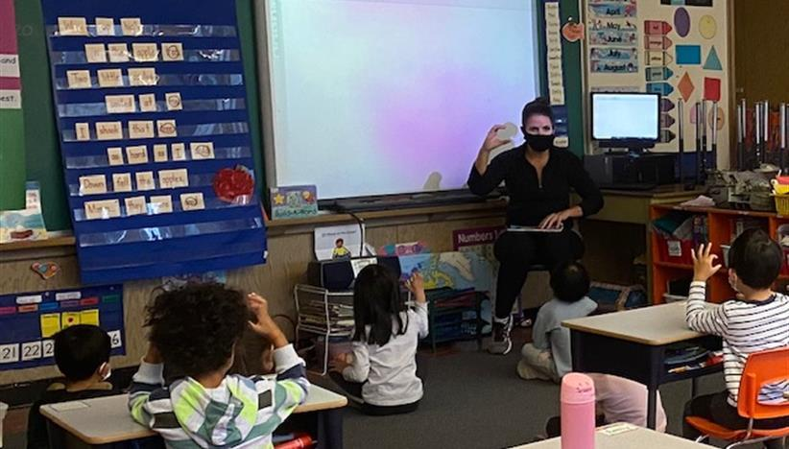

- Semester schedule
The teacher candidate learns from the Faculty Practicum Instructor the name of the practicum school, the school practicum teacher they will work with and the scope of the activity. The teacher candidate should also go to the respective school during the week and meet the practicum teacher to decide on the schedule to be followed during the semester (You are required to make an appointment in advance before meeting the practicum teacher). You should also cooperate with both the practicum teacher and the practicum instructor in the planning process. In the meantime, the teacher candidate should meet the practicum teacher and discuss issues such as how to keep in touch with him/her, what the curriculum involves, and what procedures or rules to follow. A sample schedule should be prepared and handed to the practicum instructor in the theory hour of the 2nd week in order to be checked and revised if necessary.

- A day of a teacher
The purpose of this activity is to familiarize the teacher candidate with the teaching profession and practices. Thus, the teacher candidate will gain the opportunity to observe the kind of profession that he will perform in the future. In this regard, the teacher candidate should pay attention to the following points:

1-What does the teacher do during a typical day at school? It is necessary to list a range of activities that are completed inside and outside the classroom while noting down the time allocated for each activity; since these activities should be included in the reports later (Some of the teacher activities: Preparing instructional materials for the lesson, meeting with the students individually or in groups, attending the lesson, monitoring students, attending and following other educational activities or events, resting, chatting with other teachers, discussions, grading exams, meeting with parents, etc.)

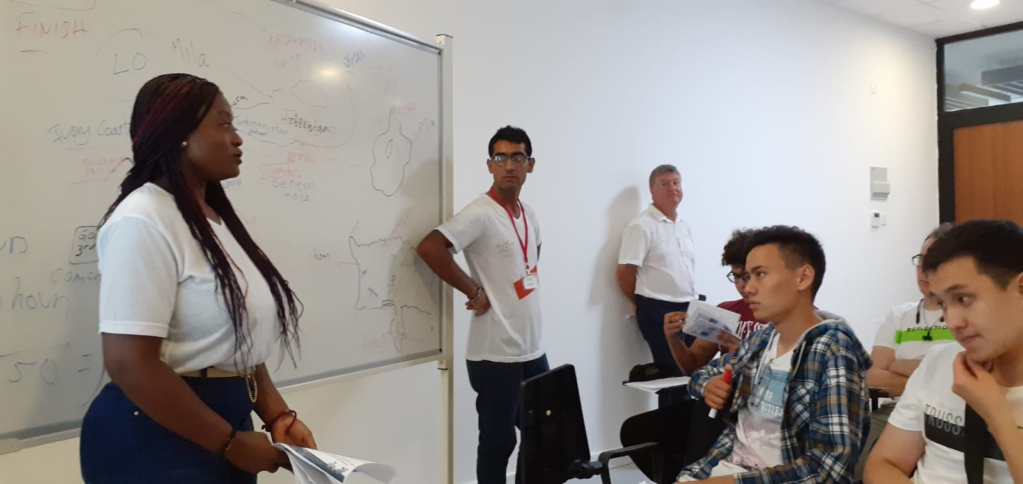

2-The prepared schedule should be shown to the teacher and he or she should be asked whether it is a good example representing typical school days. The teacher should also be asked what he or she does about their profession outside the school, and the answers given should be noted (for example, going to the library or bookshops to get resources, preparing lecture notes / materials for the next day, taking tests, contacting colleagues at other schools or private teaching institutions, etc.)

3. The teacher candidate should also take note of how s/he evaluates a day of the practicum teacher and discuss to what extent this matches with their ideal concept of evaluation.

4- Teachers may also perform activities that cannot be observed during one typical school day; such as, monitoring students, club activities, guidance activities, school-family association meetings, and cultural and artistic events and activities. The teacher should be interviewed about these activities as well and the information obtained should be included in the report.
5- During this activity, the teacher candidate should also record the problems encountered, how they were resolved, and what results or solution were provided.

6- While evaluating the teacher's work environment, the observation form-1 should be carefully filled in. The information obtained should be written in the report.

Observation Form-1 (A day of a teacher)

Behavior | Yes | No | Not observed | Explanation
Pays attention to in-class discipline
Ensures students' participation in the lesson
Deals/works with students individually or in groups
Helps students to improve their listening, understanding and speaking skills
Encourages students to ask questions and give answers
Gives homework on every lesson
Uses lesson time effectively
Communicates well in the language of instruction
Uses course materials and realia
Deals with students' personal problems
Exchanges information with other teachers
Participates in school-related events
Pays attention to his/her professional development
Complies with occupational standards
Have a good relationship with parents
Complies with school management
Establishes good relations with other teachers
Participates in cultural and artistic activities
Other

All the information gathered in these activities should be included in the teacher candidate’s report and after consultation with the practicum teacher, it should be finalized and submitted to the practicum lecturer.

Report Sample: A day of a teacher

On 23.09.2010 at 08:00 I met with my practicum instructor ………… at ........ to prepare my homework on "A day of a teacher at school". My observations on the subject are listed below.
Activities completed before the lessons
.......................................................

Activities completed during the lessons
.......................................................

Activities completed during the break time
………………………………..

Extra-curricular activities
.............……………………..

Club activities
………………………………….

- A day of a student
The purpose of this activity is to document the activities a student performs during a typical day as well as the time allocated for each activity by the student. This way the teacher candidate can learn what a student goes through and does during a school day and hence gain a better understanding of the learning processes. Students' curiosities, desires, dreams and problems should all be recorded to the extent possible by the teacher candidate (very personal questions should be avoided at this stage).

In order to prepare this assignment, the teacher candidate should meet with the school practicum teacher to decide on the student to be observed. The teacher candidate should only observe the student without any intervention. The data obtained during the observation are filled in the observation form-2.

OBSERVATION FORM-2 (A Day of a Student)

Behavior | Yes | No | Not observed | Explanation
Shows enough interest towards the lessons
Does their assignments on time
Communicates with friends individually or in groups
Has the necessary skills to listen, comprehend and speak in the lessons
Asks and answers questions during the lesson
Complies with disciplinary rules
Uses supplementary sources other than the textbook
Shows creativity in laboratories and workshops
Uses instructional materials
Establishes positive relationships with his/her teachers
Has positive relationships with the school administration
Volunteers in events such as panels, conferences
Participates in extra-curricular activities
Is interested in improving him/herself
Participates in cultural and artistic activities
Other

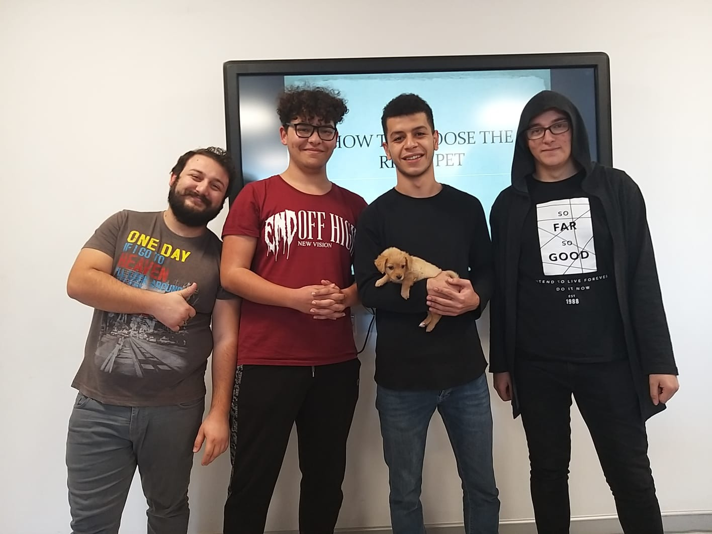
An interview should be made with the student for behavior that is not easily observable and the information obtained should be included in the report.

REPORT EXAMPLE: A DAY OF A STUDENT
I met a student named… from the ……… class after settling with my practicum teacher. My practicum instructor explained the situation to the teachers of the lessons on the date that I was going to observe the mentioned student and obtained their consent for me to participate in the lesson. I went to the ......... school at ………… on ……… to start my observations of the student and from the first lesson.
1. Lesson: Turkish
Student's in-class activities ......................
Break: Student’s activities in the break
Break: Student's activities during the break ......................
2. Lesson: Chemistry......................
Attitude towards lessons: .......
Educational club activities: ......
Sports and cultural activities: ...........................

- Planning lessons and sequencing activities

Before starting to teach a subject, in addition to the curriculum and textbook, various resource books and other information sources should be consulted and a lesson plan should be prepared accordingly. While preparing the plan, the main parts of the subject, effective and enriching teaching - learning materials, visual aids, suggestions about homework, other related activities can be identified and recorded in a file. These activities can be updated during the year as the teacher candidate collects new materials. Each time a topic is introduced, the teacher candidate can refer to the ready-made file. The selected topics can be used in the teaching and learning activities and can be sequenced accordingly. It is necessary to sequence activities into sections as it can benefit both teacher and the students.

It would be useful to divide the lesson plan into learning sections to be administered in a lesson time slot. Teaching - learning materials and realia should also be provided and arranged before the lesson starts while keeping in mind the physical setting of the classroom and the time limit for each lesson.

Preparing a lesson plan helps a lot in teaching smoothly and hence should include enough details to guide the teacher throughout the lesson. The lesson plan should not also be too detailed to confuse or misguide the teacher. As long as the plan sequences the activities to be completed by the teacher and students, it is a good lesson plan. Thus, a one-page or two-page lesson plan is usually what is expected. The following sections should be clearly stated in the lesson plan:

• Title: the subject to be taught.
• Date and time: On which day and time the lesson will take place.
• Objectives: These can be subject-specific statements, as well as students' behavior, skills, and learning techniques/strategies.
• Instructional materials and resources: Teaching-learning tools, special stationery or devices to be used.
• Activities: Clearly stating the steps in the lesson; estimated time for each step. Some of the activities to be included are: Explanation, asking questions, performing demonstrations, working on visual aids, individual work or group work, reading, writing, preparing diagrams, answering test questions, games, and working with the computer. While deciding on the type of activities, it should be taken into consideration to design activities that keep student actively engaged in the teaching-learning process.
• Evaluation: Evaluation can take place after the lesson. Reflections on students' reactions and behaviors, problems encountered during the teaching, and the teacher's own strengths and weaknesses should all be noted down for future references.

5-Observing the lessons

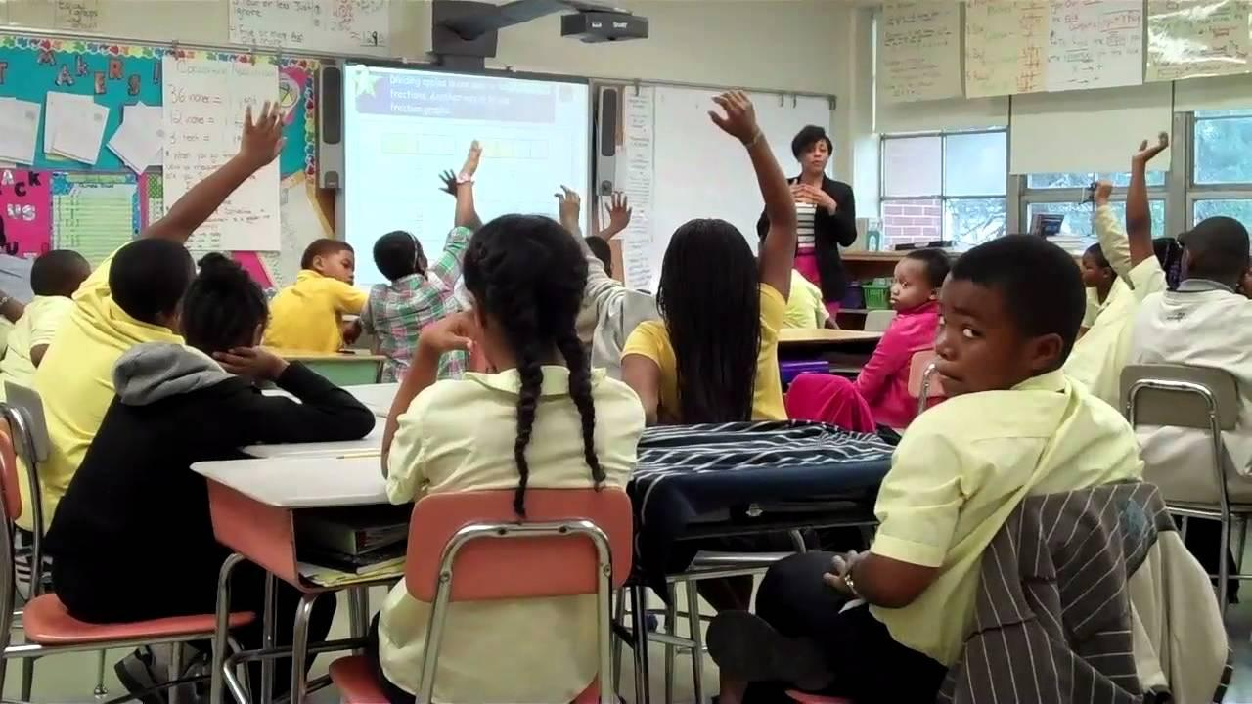
In addition to theoretical knowledge, this activity mainly concerns the observation of the implementation of teaching methods by the teacher candidate to see which of them are used and to what extent, and the duration allotted to them. The documentation of the lesson involves how the teacher candidate plans and delivers the lesson (Is the teacher the sole provider of knowledge? Does the teacher provide means for note-taking, or is the student made to report on a subject initially while support is given via clarification by the teacher afterwards?), the use books and reference sources and other supplementary educational tools and materials, questioning and answering, strategies employed in case of disciplinary issues, approaches directed at students who are unable to contribute to the class nor can provide relevant answers to the teacher’s questions, prompting text reading exercises and comprehension skills, the ability to summarize key learning points, along with methods involving classroom discussions in order to gather student interest.

The candidate teacher should discuss their findings with other teacher candidates and find common points. Meanwhile, students' reactions should be observed as much as possible.
Thus, the reflections of the individual differences of the teachers in the lessons should be determined and findings should indicate which methods affected the students more.

The candidate teacher should observe a lesson from a different branch and prepare a similar report in the same manner.

OBSERVATION FORM 3 (teaching methods)

Class: Date:
Number of students:
Name of class: Subject:
Behavior | Yes | No | Unobserved | Explanation
- Pre-class
Daily Plan Prepared
Course Materials Prepared
Helpful Resources Provided
- Beginning of Lesson
Greeting and Roll Call
Warm-up conversation
Short statement regarding important daily topic
Assignment check
Previous Topic Revision
- Delivery of the Lesson
Note-taking
Application of Question-Answer Methods
Current Examples Provided
Discussions
Key terms written on board
Explanations regarding sources
Students’ telling the subject
Fables, stories, anecdotes told
Citations from other sources
Students’ being called to the board
Demonstrations, examples, etc.
Debates
Guest lecturers invited to give lesson
Excursions and observations
Students directed to group work
Oral and written exam
Rewards and disciplinary measures applied
- End of Lesson
Topic briefly summarized
Evaluation questions answered
Homework assigned for upcoming lesson

While preparing a report on the studies, the following example can be helpful to teacher candidates.
Report Example: Lesson Observation – Teaching methods
Class: Date:
Number of students:
Name of class:
Subject:
Time | Teacher activity | Student activity
9.00 | Asked questions to class for the revision of the previous lesson | Approximately 2/3 of the class made an effort to answer
9.10 | Asked a student to explain the initial heading in the course book to start the topic of the day | Student explained. Read mostly from the source during explanation.
9.15 | Repeated the initial topic. | Listened.
9.20 | Asked questions about the topic. | Unable to provide answers.

It should also be observed and recorded in the report how behavior such as gestures, body movements, eye contact, walking around the classroom, use of the board, facial expressions, and vocal variations affect the entire lesson. Furthermore, if the teacher candidate was to deliver this lesson, the type of additional materials, preparations and methods they would use should be noted.
6- Course management and classroom control

This activity ensures that the teacher candidate observes how a teacher keeps the classroom under their control, what methods are followed for this and how the lesson is conducted. The teacher candidate should attend more than one lesson with the school practicum teacher and note the process that the teacher followed while directing the lesson and keeping the classroom under control, and discuss it with the teacher after the lesson. While preparing the report, the teacher candidate should seek answers to the questions in the table below.

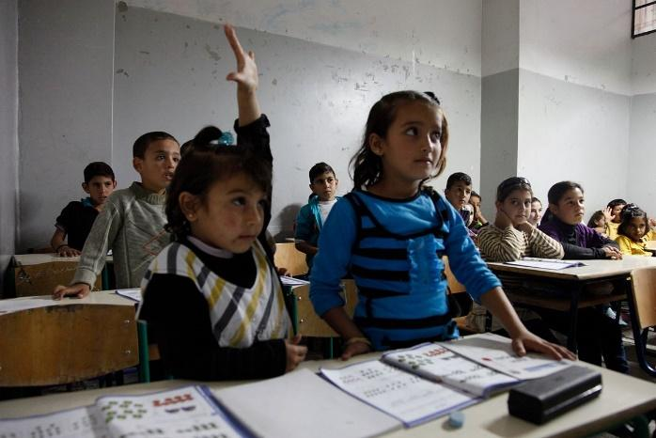

OBSERVATION FORM-4 Course Management and Classroom Control (Important points during observation)

Teacher candidate: .............................................................. Date: ...................
Class: ...................
Subject: ..............................................................
Teacher: ..............................................................
Number of students: ...........
Lesson planning: Is the teacher prepared for the lesson? What plans and preparation did the teacher make before entering the classroom?
Introduction: How did the lesson start? Did the teacher check student preparedness?
Lesson objectives: In your opinion what is the teacher trying to teach in this lesson?
Teaching-learning approach: How does the teacher organize the lesson and then progress during the lesson?
Teaching methods: What are the various activities the students undertake in the lesson? How does the teacher arrange and carry out each stage of the lesson?
Communication: Pay attention to the teacher’s tone of voice; how does the teacher make use of it when presenting, giving instructions and explaining? How does the teacher utilize feedback from the classroom?
Transitions between activities: How does the teacher ensure transition from one activity to another during the lesson?
Student management: Does classroom order proceed according to a certain plan? How does the teacher manage student behavior? Does the teacher move around the classroom or remain seated? Which method is more effective? How does the teacher react to a situation out of his or her control? What does the teacher do to prevent unwanted situations? Does the teacher address the students by name? Does the teacher explain his/her rules clearly? How do the students respond to these instructions? How is motivation secured throughout the lesson? What are the benefits of individual effort and group work? How are praise and punishment implemented? Is appropriate punishment implemented when necessary? What impact do these punishments have on the students? What does the teacher do about potential sources of disturbance? In terms of communication, what are the advantages of vocal variation, moving around the classroom, eye contact, mimics and gestures?
Lesson closure: How does the teacher conclude the lesson? Does the teacher finish with a brief summary of the lesson? Does the teacher reflect upon what happened during the lesson and discuss any details for future lessons? How long does it take to end the lesson and oversee classroom departure?
Evaluating student work: What does the teacher do to evaluate student work and progress in the lesson?

7- Making use of textbooks, preparation of worksheets and other materials
Students may be using the textbook with little information about its contents. Students should be taught how to use this book in order to understand a topic in the textbook. If students are given appropriate assistance, they can learn study skills and strategies that can give them such potential. Students must be able to understand the text, graphics, tables, flow charts, maps, etc. in the textbook to be able to perform the tasks. Otherwise, they cannot fulfill these tasks.
The teacher candidate chooses a text or a part in which they can apply a study strategy similar to the form given below. By doing so, it is ensured that the texts are selected from the parts related to the different parts of the topic and at the same time they are related to the work being done throughout the course.
A sample related to the use of textbooks
Study strategy | What the teacher does | What the students do | Follow-up process
1.Determining information to gain  What are the questions to be answered? | *Selection of a text from the textbook or text composition for this purpose  *Stating information students will find in textbook, e.g. parts of a structure and their functions; the chronological order in a historical event  *Providing instructions about the text and the work they should do | *Scanning the text to find the information sought, discussing the findings and trying to reach consensus about the information | *Sharing results between groups and discussion with teacher
2. Summarizing the information given in the text in a table | *Choosing or writing the text to search for the information to be summarized  *Designing tables to summarize information and writing table headings to help students  *Along with the copy of the text, the prepared sample of the table and the instructions to help students must be provided | *Finding the information by reading the text, completing the table by using this information | *Sharing the results between groups, discussion with teacher, *agreement on headings in the table and their scope
3. Summarizing information with a diagram or figure | *Selecting a text, or diagram about the task to be completed  *Removing all the text parts of it in the diagram or figure  *Providing students with a copy of the text, the figures or diagrams prepared and the instructions | *Using the text to write the necessary words on the diagram or figure | *Groups agree with the teacher to find appropriate words
4. Summarizing the information provided in text as a flow-chart | *Selection or composition of a text containing a process or procedure  *Preparing a flow-chart and filling in some parts. *Leaving blanks where sufficient information about the text is provided in the text  *Providing students with the text, flow-chart, and instructions about what to do | *Determining the steps necessary to complete the task, their numbers and titles with text study, without the aid of the flow-chart | *The results are shared between the groups, discussed with the teacher to come to an agreement concerning appropriate presentation
5. Sorting or organizing information provided | *Selecting a text containing a sequence of information  *Rewriting the section in the text that describes each step in the information sequence and then separating these sections from each other  *Supplying students with information about sections of the text and the instructions on what to do | *In each group there is a complete set containing all steps or sections. Groups put them into correct order. | *The final outcome is discussed and the best order is determined
6. Completion of the text in order to maintain coherence | *The selection of a text  *Removing every 5th, 7th, 9th or 12th word of the selected text - taking into account the difficulty of the text and the levels of the students - and getting the student to rewrite the text  *Supplying the students with the prepared text along with instructions on what to do | *Students read the passage, contemplate and discuss the words that might fill in the gaps and complete the text when all is agreed upon | *Together with the class the teacher reviews the words that are proposed to fill in the gaps in the text
The candidate teacher should evaluate the tasks to be given to the students and take notes regarding the sections that are difficult for the students. Also, suggestions on what kind of changes are required to improve this task must be made before submitting this report to the relevant faculty practicum instructor in the 7th week.
- Preparation of worksheets and other materials
The purpose of this is to try an activity that will make the lesson of the teacher candidate more attention-grabbing. Worksheets, and other teaching materials may be used for a particular topic or a specific group of students. A worksheet should contain the information related to the topic and the tasks to be completed by using this information.
Worksheets should be of such quality that they should be completed with little or no help from the teacher. The teacher candidate should prepare two or three worksheets on different subjects to be used with different groups in his/her lessons.
Main steps to be taken in preparing a worksheet are:
• Determining the behavior to be taught by using the worksheet.
• Determining the work that the student needs to do in order to learn the behavior.
• Deciding which student grouping will be used, individual, pair work or group work.
• Checking whether a variety of activities have been utilized and they are at the readiness level of the students, whether there are activities that all students will do jointly and whether there are additional tasks for those who finish their work early.
- Reproducing the worksheet in sufficient number.
- Testing the prepared worksheet in a classroom; taking notes of the students' behavior during the task, the questions they asked, and the difficulties they encountered.
- Evaluation of task results; for example,
Were the tasks interesting for the students?
Was the sequence followed in the task appropriate?
Was the length of the task suitable?
Were the instructions clear?
- Seeking answers to the above questions; and making changes on the worksheet if necessary.
Suggestions for preparing worksheets

Writing
Make use of words and sentences appropriate to the level of the students who will use the worksheet.
Keep your sentences short.
Underline the new words you want students to learn.
Instructions
Give instructions in the order they are to be used.
Give only one instruction at a time.
Make sure that questions or actions to be taken can be easily understood. State clearly whether the answers to the questions will be written on the worksheets or in the notebooks.
Make important points stand out by underlining them.
Tables, graphics, charts, etc.
Make sure they are simple.
Give it a title and name its parts clearly.
Use color if possible.
Page layout
Use headings that facilitate reading.
If there is more than one heading or if more than one page is used, number them.
Before you start preparing the worksheet, design a page layout.
Make sure that the sections on the worksheet are clearly visible.
Use the computer if possible.
Use different fonts for emphasis and to increase effect
Give the worksheet an eye-catching appearance; make it desirable to be read.
Preliminary experiment
Try it on one or two students before finalizing your worksheet. If there are places that are not understood, they will show you these places

- Group work
Group work is a suitable method for the following purposes:
• To encourage students to cooperate and lead.
• To encourage students to exchange ideas and opinions with each other.
• To encourage students to learn from and help each other.
• To give students an opportunity to participate in teaching-learning activities prepared in accordance with their readiness level.
It is challenging to reach these goals. It is essential for the faculty practicum instructor to plan carefully to create a teaching-learning situation that could enable students to work in harmony in groups. Various forms of tasks and activities could be designed as group work such as problem-solving, research project, presentations, games and simulations, project work and experiments.
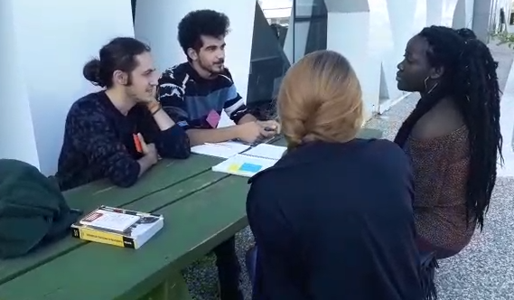
Teacher candidate should prepare lesson plans to benefit from group work and consider objectives that could be met via group work before class. Some of these objectives are as follows:
- Develop social skills such as cooperation, tolerance and co-learning,
- Allow students to join teaching-learning tasks prepared according to their level of readiness,
- Encourage student groups to undertake various teaching-learning tasks and various ways of thinking,
- Increase diversity, etc.
Teacher candidate should plan group formation and group tasks according to the goals s/he sets for group work. The following questions are raised for this purpose:
- What will be the size of the groups and how will they be formed? Who will make this decision? You or the students?
- Will the groups be formed by the same students who participated in the last group task?
- Will the groups be formed according to students’ readiness, interest, behaviour or friendship dynamics?
- Will the physical arrangement of the classroom, table, chairs, desks, etc. be altered to facilitate group work?
- What will the principles be in presenting class projects, motivating students and providing guidance in order to begin lessons in a positive manner?
How should an introduction be planned?
- How will the teacher ensure that each group is working on a project appropriate to their level?
- Will the teacher plan additional tasks for groups who finish their projects earlier than others?
- What should the teacher do for an ending that enables learners to share their experiences with each other, exchange opinions on what has or has not worked, share interesting results with the rest of the class, identify whether the learning objective has been met and express expectations for the future?
It is necessary to plan an ending.
In order to carry out the planned lesson, the teacher candidate may ask the school practicum teacher or a friend who is a teacher candidate to observe the lesson and record his/her observations on a form to provide feedback.

9- Questioning exercises, test preparation, scoring and analysis

Observing questions in class
The purpose of this activity is to observe how often the question-answer method is used, what effect it has on students and whether the method has achieved its purpose. In order to carry out the activity, the teacher candidate should ask the school practicum teacher to participate in a lesson in which s/he will apply the method. Before entering the class, a plan should be prepared and questions should be provided. During the lesson, one should pay attention to whether the teacher chooses the students who want to answer after asking the question randomly, according to the order of student numbers, the sitting arrangement or nominating those who raise hands.
During observations, the following points should be considered: Did the teacher prepare the questions him/herself? Are the questions clear and comprehensible? Are they suitable for the student’s level? Are open-ended questions or multiple choice questions being asked? Which one do the students respond more comfortably? Are the students given enough time to think about the answers? Are clues given when a question cannot be answered? Does the teacher impose his own truths? Are there any rewards (such as giving an oral grade)? Does the teacher encourage the students to respond with gestures? What types of questions (display, information, open-ended) are answered more?
An observation form like the one below can help the teacher candidate during observations.
Class: Date:
Number of students:
Title:
Topic:
Qs | Students’ answers |  |  |  | Teachers’ feedback
 | Correct | Partial | Incorrect | No answer | No feedback | Praises | Scolds | Asks another question for elaboration | Gives hints | Asks another student
1
2
3

In addition, in this activity, the teacher candidate tells the practicum teacher that s/he wants to do an exercise by selecting a part of the work carried out in the classroom and using these questions during his/her teaching. The teacher candidate asks the school practicum teacher to determine when s/he can experiment with the questions and which part of the lesson can be allocated for this purpose. The questions are prepared by examining the part of the lesson determined together by the practicum teacher. When deemed necessary, questions are reviewed with the faculty practicum instructor or school practicum teacher. While the plan is implemented in the classroom, you can ask for help from the practicum teacher, if possible.
While practicing asking questions, it is important to give the students enough time to answer, correct the wrong answers, give hints to complete the partial answers, encourage the students to ask to speak, and reward them.

Test preparation, scoring and analysis
For this task, the teacher candidate prepares a testing plan for the last unit(s) of a class related to the field. A table is created for this part of the course. The number of questions and the scores in each section is shown in the table. The types of test items (questions) to be used in the test and, if more than one type will be used, how many items will be included in the test from each of them are determined. If it is planned to give different scores to the answers of the questions, a scoring key is prepared. A test, then, is prepared and applied in the classroom; results are analyzed. It should not be forgotten that the test to be prepared should assess the knowledge, skills and processes that are aimed to be acquired in the course on the one hand, and the subject or activities used as a tool in the course on the other, in accordance with their weight in the course (This is called content validity).
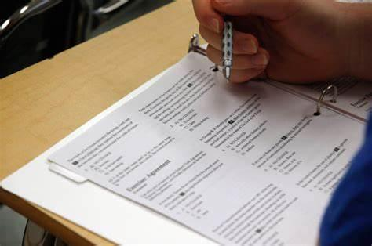
The teacher candidate scores the answers, analyzes the tests on these scores, calculates the central tendency, variability (variance) measures, and tries to predict the reliability and validity of the test scores. If the items (questions) in the test are of multiple-choice type, item analysis is performed on the answers given to them; the difficulty and discrimination of the items are predicted, and the functionality of the distractors is reviewed to improve the items.
After implementing the test, the answers to the following questions are sought while evaluating the test:
• According to the information about the learning levels of the students in the class, are there any items that fewer or more students than expected gave correct answers? Are these items of good quality (without any defect) in other respects?
• According to the information about the learning levels of the students in the class and the scores they got from the test, are there any items that do not differentiate high-achieving students from the others or appear to make a distinction contrary to what is expected? What can be done to make them distinctive in the expected direction and to increase their discriminatory power?
• Has the expected progress been achieved in line with the objectives in the part of the course?
• If only one unit was covered in the test, in which parts of this unit, if more than one unit was addressed, in which of these units was the learning level the highest and the lowest?
• What are the common misunderstandings and learning gaps about the topics, skills and processes covered in the test?
In addition, information about the written and oral exams used by the teacher should be compiled: How many written and oral exams are held? How are the exams announced? What is the number and types of questions and how is the exam evaluated? How is the result announced to students and how is feedback given?

10- Evaluation of student work
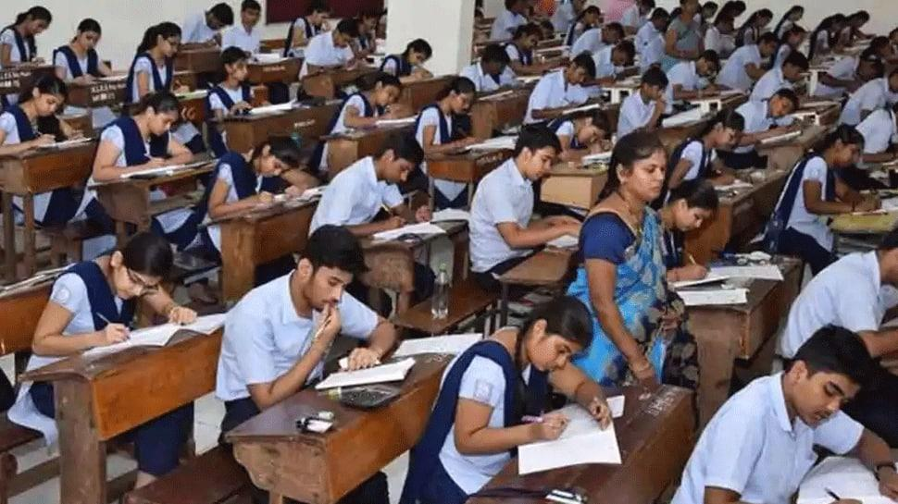
The teacher candidate talks with the school practicum teacher and learns how much time he or she spends every week for the evaluation of student work. He or she can ask the school practicum teacher questions such as: How much of the written work do you examine and how much of them do you grade? Do you need to examine some tasks more meticulously than others? What kind of a grade (assessment) scale is used at school? What are the criteria for awarding the highest, middle or lowest grades? After learning the answers to such questions, the teacher candidate observes what kind of records are kept regarding student achievement by looking at the notebook or student files. Permission is obtained from the teacher to jointly review and grade specific work of some students. These may be answers given to questions from a previous exam or the results of a previous assignment. It should not be forgotten that the work to be examined should be related to the subject being learned in the classroom. While working with the teacher, the following points should be emphasized about the criteria of the teacher while grading the evidence related to: the student's level of knowledge, the degree of understanding of a task, the neatness of the study, the degree of compliance with punctuation rules, and the presentation skills. When a task is to be graded, they should decide, before starting the review, which aspects of the work will be examined and how many points will be awarded to these parts. The scores to be given should be determined according to the degree of excellence expected in the task; it should not be based on the comparison with other students ’products. Subjective comparison of a student's work with those of other students' should be avoided.
The teacher candidate takes another sample of the students' work by meeting with the school practicum teacher. These can again be students' exam papers or homework. A photocopy of these works is first made. Notes are written on these to support and guide students. These notes should be treated with such care that the student can produce better works on the same subject after reviewing the notes. Students' work should be quickly reviewed and evaluated. By consulting with the practicum teacher, the results should be delivered to the students while their interest in the subject continues.
Positive feedback can be given to the students in the classroom by mentioning the names of the students who submit high quality products. The points that concern all students in the classroom are explained, e.g. the extent to which the target level has been reached in the task, the points at which all students are successful and common misunderstandings. Samples of high quality works are given; poor samples are not emphasized. It is appropriate to meet students who require additional individual support subsequently so that they can achieve the expected level. Students' self-confidence may be damaged by negative feedback to their work; it should be kept in mind that constantly facing negative criticism or constantly getting low grades can endanger the student's interest and effort.

Additional activity
It will be an interesting activity to examine whether the grades given to students' work differ from teacher to teacher. If possible, take photocopies of one or two students' works and ask your friends who are also teacher candidates to carefully examine and grade them independently.
Try to answer the following questions by looking at the results: -What difference is there in the grades given for the same task (product)? Why? - What does each of the grading teachers want to see in the product they evaluate? - What grades did each of the grading teachers award to the work (product) they evaluated?
Ensure consensus on a grading scale to show what grade will be assigned to a work of any quality (product). Grade the works you have graded before using this grading scale on which you have agreed. Have the differences between grades awarded by different people to the same work disappeared in this final assessment? Remember that students are usually asked open-ended questions as in common written exams, and that they think of the answers to these questions and write them accordingly. Now, to what extent do you think that a process of examining and grading the answers to such questions, is a reliable and objective process?

11- The management, facilities and problems of the school
With this task, the teacher candidate will have information about:
1-The duties and responsibilities of the principal and vice principals,
2-The adequacy of the number of teachers and administrative staff in the school
3-The school's amenities and necessities such as classroom, library, laboratory, workshop, gym, yard, canteen, etc.
4- The equipment such as computers, slide projectors, cameras, camcorders, overhead projectors, laboratory equipment, photocopy machines, maps, TV and videos, models, sections, pictures, posters, tables, etc.
Information to be collected about materials and written sources
Books
- The titles of the textbooks used in different classes
- Your evaluation of the textbooks
- Reference books given to the teacher
- Resource books suitable for the level of the class in the school library
- Other books used by the students
- Worksheets and other resources prepared by the teacher
- Visual material production tools and facilities that students can use to prepare their own materials
- What is available to use and where are they? Who can or do use them? Can you see them?
- What are the computer and word processing (electronic typesetting) facilities?
- What copying tools are available?
Audio-visual materials
- Overhead projector, transparencies, pens for writing on transparencies
- Video viewer, video films (cassettes)
- Computers and software that students can use in the classroom
Other materials
- Are maps, models, charts, slides, etc. available?
- Who uses them?
- Where are these stored?
- How can you use them?

12- Teaching
Each teacher candidate should teach at least two class hours to cover all the activities done so far. For this, the class and subject to be taught are determined in advance with the school practicum teacher. The teaching is done after completing planning, researching resources, preparation of the lesson plan, acquiring equipment, preparation of evaluation questions related to the subject. Then, opinions about the lesson, what has been done and what could not be done, the teacher's advice and criticism are presented to the faculty practicum instructor in a report.
- Evaluation of Teaching Practice Course
For the Teaching Practice 1 course, teacher candidates' midterm grades are given by the school practicum teacher based on the following criteria:
1-The teacher candidate’s attendance and carrying out activities,
2-The teacher candidate’s attitudes and behaviors suitable for the teaching profession,
3-The teacher candidate’s relationship with the staff and students in the practicum school.
Final exam grades for the Teaching Practice 1 course are given by the faculty practicum instructor, taking into account the files prepared by the teacher candidates.

Teaching Practice I Assessment Breakdown
Methods of Assessment
Classroom Teaching %30
Microteaching %30
Reports %40
- Classroom Teaching will be mainly assessed by the practicum school teacher. Faculty practicum instructor may also assess classroom teaching either by visiting classes or watching the recordings.
- Microteaching will be assessed in faculty classes by the faculty practicum instructor and peers.
- There will be 7 reports altogether. The number of reports to be taken into assessment will be decided by the faculty practicum instructor according to the changing conditions.
RUBRICS FOR TEACHING PRACTICE- I REPORTS
Name of the Student:
Name of the School:
FINAL GRADE:
Reports | Punctuality (10pts) | Organization  (10pts) | Language  (20pts) | Content  (50pts) | Completeness  (10pts) | TOTAL
Report 1
Report 2
Report 3
Report 4
Report 5
Report 6
Report 7
Report 8
Report 9
Assignment
Report 10
Report 11

Faculty Practicum Instructor
Comments:

ASSESSMENT FOR MENTORSHIP
Name of the Mentor: Names of the Mentees :
Dates of Meetings: Attendance of the Mentees:
 | 1st meeting  (....minutes) | 2nd meeting  (....minutes) | 3rd meeting  (....minutes) | 4th meeting  (....minutes)
Readiness (10pts)
Language (10pts)
Voice (10pts)
Introduction and conclusion (10pts)
Presentation (10pts)
Timing (10pts)
Giving feedback (10pts)
Incorporating the sample material (10pts)
Involvement of Students (10pts)
Rapport with the students (10pts)
TOTAL (100pts)

COMMENTS (by the mentor):
COMMENTS (by the instructor):

PART III: IMPLEMENTATION OF TEACHING PRACTICE 2
A-Scope of the course and syllabus
Course Description: This course aims at preparing prospective teachers for practice teaching and real classroom situations in schools. It consists of 2 theoretical hours and 6 practice hours. Theoretical part is carried out at the university under the supervision of course instructor. It is mainly the revision of necessary background information for the prospective teachers to carry out the tasks and activities set together with the course instructor and school teacher. It also covers the checking of lesson plans, tasks, worksheets, and exams to be administered at practice schools. In addition to these, discussions on problems encountered at practice schools, suggestions on how to solve them, good and bad examples, giving feedback to the students are included in the theoretical hours.
Practice part is carried out at practice schools under the supervision of school teachers. Students are to teach at least three full class hours during the term and to take part in the teaching activities at practice schools as much as the school teacher and the school principal demand and allow. All of these are observed and assessed by the school teacher. Only one of the full class teachings should be observed and assessed by the course instructor.
Course syllabus: Even though it is advised not to have a strictly set syllabus for this course as it needs to be designed according to the needs of the teacher candidates and schools, a flexible syllabus contains some of the following items as needed:
Week 1 | Introduction to the course  Code of Conduct
Week 2 | Reviewing Lesson Planning/goals and objectives  The use of tasks and activities,
Week 3 | Report and Presentation
Week 4 | Classroom language and interaction: asking questions and giving feedback
Week 5 | Report and Presentation
Week 6 | Error correction: giving and evaluating assignments
Week 7 | Report and Presentation
Week 8 | Mid-term Examination Period
Week 9 | Preparation, administration and evaluation of exams: keeping records of student work
Week 10 | Use of classroom equipment: Board, smart board, bulletin board, etc.
Week 11 | Extra-curricular activities
Week 12 | Micro-teaching
Week 13 | Micro-teaching
Week 14 | Micro-teaching
Week 15 | Portfolio submission and course evaluation

B- Teaching practice activities and report writing principles
SAMPLE TASKS FOR THE COURSE
- PARTS OF A LESSON PLAN
- Read the sample lesson plans and ask the school teacher to share a lesson plan s/he uses in his/her lessons and answer the following questions.

1 | How many main parts are there in a lesson plan?
2 | What are the names of the parts of a lesson plan?
3- | What is the aim of each part of a lesson plan?
3 | What are the roles of the teacher and the students in each part of the lesson?
4 | How much time should be allotted to each part of the lesson plan?

- Prepare a Lesson plan for the practice school and try to use at least one part of it in the classroom. See Appendix 1 for the format.

- WRITING GOALS AND OBJECTIVES
- Read the goals and objectives of sample lesson plans and answer the following questions:
1 | What does the goal of a lesson express?
2- | What do the objectives of a lesson cover?
3- | What is the difference between goals and objectives?
4- | Which sentence frames are used to write goals and objectives?

- Write goals and objectives for 4 different lessons (listening, speaking, reading and writing).
Name of the lesson
Goal of the lesson
Objectives of the lesson

- THE USE OF TASKS AND ACTIVITIES
- Observe the class, choose two tasks or activities and answer the following questions
1 | What is the type?
2 | What is the purpose?
3 | How many students are involved?
4 | Which language skills are involved?
5 | What is the interaction type?
6 | Does it engage learner’s interest?
7 | Is there a primary interest on meaning or on form?
8 | Is there a goal or an outcome?
9 | Is completion a priority?
10 | Does the activity relate to real life activities
- Prepare one activity and one task , apply them in classroom and write your reflections

- USE OF SONGS AND GAMES
- Observe a lesson, interview your teacher and answer the following questions
1 | Does the teacher ever use songs?
2 | Does s/he ever use games?
3 | Are the songs provided by the course book/school/the teacher?
4 | Are the games provided by the course book/school/the teacher?
5 | In which part of the lesson are the songs and games used?
6 | For which purpose are the songs generally used?
7 | For which purpose are the games generally used?
8 | Which technique does the teacher use while using the songs?
9 | Which technique does the teacher use while using the games?
10 | What is the effect of the use of games and songs on the students?

- Prepare a song or game to be used in your lesson and practice it.

- Write your reflections.

- CLASSROOM LANGUAGE AND INTERACTION

- Observe the class and answer the following questions
1 | How does the teacher greet his/her students?
2 | What does the teacher do as warm-up?
3 | How does the teacher introduce new activities?
4 | What does the teacher say to give feedback?
5 | What does the teacher say to praise students?
6 | What expressions does the teacher use to motivate his/her students?
7 | What sentences does the teacher commonly use to give instructions?
8 | How does the teacher divide students into pairs and groups?
9 | How do the students contribute to classroom interaction?
10 | What does the teacher say to end an activity, task, group work, etc.?
11 | What does the teacher say to draw attention?
12 | What does the teacher say while assigning homework?
13 | How does the teacher end class?
14 | How does the teacher ensure that the instructions/explanations are clear?

- Search on the net and make a list of most frequently used classroom language.

- Take notes about the most frequently used classroom language by the teacher.

- ASKING QUESTIONS and GIVING FEEDBACK
A-Observe a lesson at practice school and answer the following questions:
1 | Who asks the questions in the lessons?
2 | How does the teacher choose who will answer?
3 | What types of questions does the teacher ask?
4 | Is there an order the teacher follows while asking questions?
5 | Does the teacher usually prefer written questions or oral questions?
6 | In which part of the lesson does the teacher use oral questions?
7 | In which part of the lesson does the teacher use written questions?
8 | What does the teacher do when the answer is correct?
9 | What does the teacher do when the answer is wrong?
10 | How does the teacher motivate the students to answer the questions?

- Write examples of questions asked by the school teacher and identify their type and purpose.

- Prepare your own questions and ask them in the classroom.

- Write your reflections

- GIVING INSTRUCTIONS

- Observe the classroom teacher and write the instructions s/he frequently uses during the lesson.
MOST FREQUENTLY USED INSTRUCTIONS BY THE TEACHER

- Write an alternative set of instructions to be used in the classroom.
MY LIST OF INSTRUCTIONS

- ERROR CORRECTION
- Answer the following questions about error correction:
1 | What are the types of error correction?
2 | In your opinion which is the best type of error correction? Explain why.
3 | In your opinion which is the worst type of error correction? Explain why.
4 | Which errors should be corrected?
5 | When should errors be corrected?
6 | What are the constructive effects of error correction?
7 | What are the destructive effects of error correction?

ERROR CORRECTION IN CLASS
- Observe a lesson and answer the following questions
1 | Does the teacher correct the errors of the students? How often?
2 | Does the teacher correct the mistakes of the students? How often?
3 | Which errors does the teacher correct most? Grammar, pronunciation, knowledge?
4 | Which error correction techniques does the teacher frequently employ?
5 | Does the teacher correct the errors immediately after they are made or at the end of the activity?
6 | What is the reaction of the students to error correction?

- Make a list of the errors made by the students and note how the teacher corrected them.
- Try to correct the errors and mistakes the students make and write your reflections.

- The use of classroom equipment
- Observe the teacher and answer the following questions.
1 | Can the students see and read what is written on the board?
2 | Does the teacher give the students time to copy what is written on the board?
3 | Is the board divided into panels?
4 | Does the teacher use colored chalk/capital letters to emphasize important parts?
5 | Is the handwriting legible?
6 | How often does the teacher stop writing to make explanations?
7 | How often does the teacher erase the board?
8 | Is the aim/subject of the lesson written on the top
9 | Does the teacher allow students to write on the board?
10 | How does the teacher correct any mistake on the board, if any?
Note: If there is a smart board in the class write your observations and comments on how the teacher uses it.
- Use the blackboard in the lesson for one part of the lesson and write your reflections.
- PREPARATION, ADMINISTRATION AND EVALUATION OF EXAMS,

Interview how the practicum teacher prepares the exams, how much time she or he spends on preparing the exams, what does he/she take into account while preparing the questions (pages, chapters, item difficulty, item facility of the questions, question formats, receptive or productive tasks)
How is the exam announced?
How long does each exam last? What factors are considered in setting the length of exams (time duration)?
How are the results of the exam announced? Does the teacher read the results aloud or does he/she keep the results confidential?
Are there any supplementary tasks or activities for the underachievers or overachievers in the exam? What does the teacher do with the underachievers in the exam? Giving extra instruction, etc.
What is the role of subjective or objective assessment?
- EXTRA-CIRRICULAR ACTIVITIES
- Interview your school teacher and follow the following questions.
1 | Is there an English Club at the practice school?
2 | Are some special days celebrated in English?
3 | Do the students perform some drama activities throughout the term?
4 | Do the students prepare a wall newspaper in English?
5 | Are the students given opportunities to watch films or videos in English outside the class hours?
6 | Is there an English book club to help students exchange books?
7 | Do the students have the opportunity to read daily newspapers or magazines in English at school?
8 | Do the students have whatsapp or similar groups to communicate with each other in English?
9 | Are debates and competitions in English organised outside the class hours?
10 | Are families ever invited to school to observe their children’s performance in English?
- Design an extra-curricular activity in detail for the students, write goal and objectives, necessary materials and the procedure step by step.

C- Evaluation of Teaching Practice Course
Teaching Practice II Assessment
Methods of Assessment
Classroom Teaching %40
Microteaching %20
Reports %40
- Classroom Teaching will be assessed both by the school teacher and the Faculty practicum instructor. %20 by the school teacher and %20 by the faculty practicum instructor.
- Microteaching will be assessed in Faculty classes by the faculty practicum instructor and peers.
- There will be 7 reports altogether. The number of reports to be taken into assessment will be decided by the faculty practicum supervisor according to the changing conditions.
ASSESSMENT RUBRICS FOR TEACHING PRACTICE II REPORTS
Name of the Student: Name of the School:
GRADE:
Reports | Punctuality (10pts) | Organization  (10pts) | Language  (20pts) | Content of Observation Report (20pts) | Content of Practice (20pts) | Reflections  20pts | TOTAL
Report 1
Report 2
Report 3
Report 4
Report 5
Report 6
Report 7
Report 8
Report 9
Report 10
Report 11
Report 12

Faculty Practicum Instructor:
Comments:

- Teaching Practice Evaluation Form
FINAL INTERNATIONAL UNIVERSITY
FACULTY OF EDUCATION
ENGLISH LANGUAGE TEACHING DEPARTMENT
ELTE 402 TEACHING PRACTICE EVALUATION FORM

Trainee’s Name and Surname: Number:
Class and teaching topic:
 | Grade | Comments
A. TEACHER (20 %)
1 Appearance (dress, posture)
2 Personality (presence, attitude, general Style)
3 Ability to establish rapport
4 Voice-audibility, intelligibility, ability to project
5 Level of confidence
B. LANGUAGE (20 %)
1 Correctness of structure, vocabulary, register
2 Fluency
3 Sensitivity to pupils’ level
4 Pronunciation, stress and intonation
5 Handling of his/her own mistakes, if any (aware of them? Ignore them? Self-correct?)
C. PLANNING (20 %)
1 Goals and Objectives
2 Using appropriate tasks and activities
3 Using necessary materials and equipment
4 Relating to necessary background knowledge
5 Clarity and sequencing
D. TEACHING (20%)
1 Achievement of objectives
2 Presentation (text, structure, vocabulary)
3 Questioning: graded, directed, appropriate
4 Use of board, computer, projector
5 Use of aids (visuals in the text, on the blackboard, from outside)
E. MANAGEMENT (20%)
1 Control of Class
2 Encouragement of pupils-ability to involve all
3 Overall pace, maintenance of interest (flexibility, creativity, changes of activity)
4 Awareness and correction of pupils’ errors
5 Checking of learning, giving feedback
Overall Assessment/TOTAL GRADE:
Observer’s Name:
Signature:
Date:
Part IV: Micro-teaching
- Prepare a short lesson plan in the light of previous lectures, discussions, etc. to do with some aspects of learning and teaching. Focus on a few specific skills, such as questioning techniques, explaining, etc.;
- Give an observation sheet to all the students and instructors in the class;
- Teach it in a small class for 10-15 minutes;
- Receive feedback from all the observers;
- Improve your lesson plan according to the feedback;
- Teach it again.
- Write your reflections;
- Put the first and second lesson plans, feedback forms by observers and your reflections into your file.
Note: The items in Micro-teaching Observation Form change according to the skills and techniques focused. Peer Therefore, Observation Form in the appendix should be adapted into specific situations.

Assessment Rubrics for Micro-teaching
Micro Teaching Peer Observation Form 1
FINAL INTERNATIONAL UNIVERSITY
FACULTY OF EDUCATION
ENGLISH LANGUAGE TEACHING DEPARTMENT
ELTE 402 PEER OBSERVATION FORM
Name of trainee: Date:
Topic: Observer:
 | Yes | No | Comments
1 Is the aim of the lesson clear?
2 Is the teacher's pronunciation clear?
3 Does the teacher speak naturally?
4 Does the teacher use classroom language effectively?
5 Does the teacher seem interested in the lesson?
6 Are the stages of the lesson clear?
7 Is there a smooth transition between the stages of the lesson?
8 Does the teacher use the board effectively?
9 Do students participate actively?
10 Does the teacher smile often?
11 Does the teacher use visuals effectively?
12 Does the teacher encourage questions?
13 Does the teacher give equal attention to all the students?
14 Does the teacher maintain eye contact with the students?
15 Does the teacher vary his/her questioning styles?
16 Are the explanations clear?
17 Does the teacher encourage real use of the target language?
18 Does the teacher use a variety of activities?
19 Does the teacher use time effectively?
20 Does the teacher use classroom language effectively?
General comments:

Appendices
Lesson Plan Formats
Sample 1

Lesson plan:
Level
Language | Grammar:  New vocabulary:  Review vocabulary:
Objectives | By the end of this lesson, students will be able to
Materials
Warm-up
Capture their attention
Connect to prior knowledge and experiences
Review language students have learned
Pre-teach new vocabulary or expressions
Preview the topic / pictures / titles / cover, etc.
Prediction
Presentation
Studying the content
Comprehension check
Check predictions
Practice
Review and retell
Application
Activity
Activity
Assessment
Monitor progress
Assessment
Follow-up
Homework

Attachments:

Attach paper-based materials to your lesson plan
Sample 2

PART I
Name of Class
Group
Unit
Topic
Time
PART II
Learning outcome
Methods and techniques
Materials
Teaching learning process
Warm-up
Motivation
Revision
Presentation
Guided Practice
Independent Practice
Wrap-up
PART III
Assessment
PART IV
Evaluation of the lesson

Attachments:

Attach paper-based materials to your lesson plan

APPENDIX 2: Teaching Practice Documents
- Letter to be written to the principals of Practice Schools

ULUSLARARASI FİNAL ÜNİVERSİTESİ
EĞİTİM FAKÜLTESİ İNGİLİZCE ÖĞRETMENLİĞİ BÖLÜMÜ
UYGULAMA OKULLARI

Sayın ............................................................Müdürlüğüne,

Ekte ismi/isimleri bulunan öğrenci/öğrenciler (öğretmen adayı/adayları) rehberliğinizde bir dönem Öğretmenlik Uygulaması dersinin haftada altı saat uygulamasına katılacaklardır. Öğrenciler bu dönem süresince rehber öğretmenleri ile birlikte tüm eğitim ve öğretim atkinliklerine katılacaklar ve okul idaresinin izin verdiği zaman ve süre içerisinde eğitim ve öğretim etkinliklerini kendileri yürüteceklerdir. Öğrencilerin kısa süreli ders sorumluluğunu almalarının yanı sıra dönem boyunca 4 tam dersi yürütmeleri zorunludur. Öğrencilere, bu dönem sonunda rehber öğretmeni tarafından not verilecek ve müdürlüğünüzce onaylanacaktır. Not verme 100 (yüz) puan üzerinden ek formda belirtilen ölçütlere göre yapılacaktır.

Saygılarımızla.

Eğitim Fakültesi Dekanı Ders Öğretim Üyesi

No | Öğrenci No | Öğrenci Adı Soyadı | Dönem Notu
1
2
3

Okul Müdürü Rehber Öğretmenin

Adı Soyadı : Adı Soyadı :
İmzası : İmzası :
Tarih : Tarih :

- Teacher Trainee’s Attendance Sheet

TEACHER TRAINEE ATTENDANCE SHEET
FINAL INTERNATIONAL UNIVERSITY
FACULTY OF EDUCATION
ENGLISH LANGUAGE TEACHING DEPARTMENT
PRACTICE SCHOOL:
Date | The class attended / the number of hours | Name and Surname of Trainee | Signature | Name and Surname of School Teacher | Signature
 | (6)
 | (6)
 | (6)
 | (6)
 | (6)
 | (6)
 | (6)
 | (6)
 | (6)
 | (6)
 | (6)
 | (6)
 | (6)
 | (6)

Okul Müdürü: İmza

Mühür:

- Teaching Practice Evaluation Form
FINAL INTERNATIONAL UNIVERSITY
FACULTY OF EDUCATIONAL SCIENCES
ENGLISH LANGUAGE TEACHING DEPARTMENT
ELTE 402 TEACHING PRACTICE EVALUATION FORM
Trainee’s Name and Surname: Number:
Class and teaching topic:
 | Grade | Comments
A. TEACHER (20 %)
1 Appearance (dress, posture)
2 Personality (presence, attitude, general Style)
3 Ability to establish rapport
4 Voice-audibility, intelligibility, ability to project
5 Level of confidence
B. LANGUAGE (20 %)
1 Correctness of structure, vocabulary, register
2 Fluency
3 Sensitivity to pupils’ level
4 Pronunciation, stress and intonation
5 Handling of his/her own mistakes, if any (aware of them? Ignore them? Self-correct?)
C. PLANNING (20 %)
1Goals and Objectives
2 Using appropriate tasks and activities
3 Using necessary materials and equipment
4 Relating to necessary background knowledge
5 Clarity and sequencing
D. TEACHING (20%)
1 Achievement of objectives
2 Presentation (text, structure, vocabulary)
3 Questioning: graded, directed, appropriate
4 Use of board, computer, projector
5 Use of aids (visuals in the text, on the board, etc.)
E. MANAGEMENT (20%)
1 Control of Class
2 Encouragement of pupils-ability to involve all
3 Overall pace, maintenance of interest (flexibility, creativity, changes of activity)
4 Awareness and correction of pupils’ errors
5 Checking of learning, giving feedback
Overall Assessment/TOTAL GRADE:
Observer’s Name:
Signature:
Date:

Principal of the practicum school

- Peer Observation Form 1

FINAL INTERNATIONAL UNIVERSITY
FACULTY OF EDUCATIONAL SCIENCES
ENGLISH LANGUAGE TEACHING DEPARTMENT
ELTE 402 PEER OBSERVATION FORM
Name of trainee: Date:
Topic: Observer:
 | Yes | No | Comments
1 Is the aim of the lesson clear?
2 Is the teacher's pronunciation clear?
3 Does the teacher speak naturally?
4 Does the teacher seem interested in the lesson?
5 Are the stages of the lesson clear?
6 Does the teacher use the board effectively?
7 Do students participate actively?
8 Does the teacher smile often?
9 Does the teacher use visuals effectively?
10 Does the teacher encourage questions?
11 Does the teacher give equal attention to all the students?
12 Does the teacher maintain eye contact with the students?
13 Does the teacher vary his/her questioning styles?
14 Does the teacher encourage real use of the target language?
15 Does the teacher use a variety of activities?
General comments:

- Student Observation Form

LESSON OBSERVATION FORM (For young learners)
Name : _________________________ Class ________________________
Date : _________________________ Time & duration: ___________________
 | Observation | Yes/No | Comments, if any
1. | T has a lesson plan with clear objectives and stages.
2. | T has used appropriate activities/techniques to reach the objectives s/he set for this lesson.
3. | T has started the lesson in a way to engage and interest learners.
4. | T has allotted appropriate amount of time for each activity.
5. | T has planned a logical and smooth transition and flow.
6. | T has had and projected self-confidence and enthusiasm.
7. | The lesson was fun.
8. | The students were active (learn by doing).
9. | T has included at least 2 different interactions.
10. | T has included at least 3 different learning styles/intelligences.
11. | T has used authentic contexts/situations.
12. | T has used realia or other teaching aids to promote comprehensible input.
13. | T has encouraged personalization.
14. | There was plenty of comprehensible input.
15. | T has short tasks or has broken down tasks into smaller tasks.
16. | There was no explicit grammar teaching.
17. | T has modeled tasks and clarified expectation.
18. | T has kept the tempo throughout the lesson.
19. | T has tried to create a warm and fulfilling learning environment and experience for all students.
20. | T has used his/her voice, body language, humor to facilitate learning.
Additional comments if any

- Trainee’s Diary

FINAL INTERNATIONAL UNIVERSITY
FACULTY OF EDUCATIONAL SCIENCES
ENGLISH LANGUAGE TEACHING DEPARTMENT
ELTE 402 TRAINEE’S DIARY
Trainee’s Name and Surname: Number:
Class and teaching topic:
- Please mark the item(s) appropriate to your Planning by placing a check mark (√) in the space after each:
- I considered the following items while planning my lesson:
1 | Aim the lesson
2 | Learning outcomes
3 | Course syllabus
4 | Student’s and/or Teacher’s book
5 | School Curriculum
6 | Student needs
7 | Others (please specify) :

- I included the following stages and sub-stages in my lesson plan:

1. | Lead-in: | a. Motivation/Warm-up
 |  | b. Aim of the lesson
 |  | c. Learning outcomes
 |  | d. Review of Necessary Background Material
2. | Presentation | a. Attention Pointer
 |  | b. Examples
 |  | c. Rules and/or explanations
3 | Practice and or/Production Activities
4 | Consolidation
5 | Homework
5 | Timing for each stage
6 | What aids to be used
7 | Others (please specify) :

- Please write your reflections about your teaching experience.

G-
FINAL INTERNATIONAL UNIVERSITY
FACULTY OF EDUCATIONAL SCIENCES
ENGLISH LANGUAGE TEACHING PROGRAM
Teaching Practice 1 Observation Form
.......................... Academic Year .......... semester
The name of the teacher candidate: Number:
Name of Practicum School: School Practicum Teacher:
Faculty Practicum Instructor:
Date | Class | Title of task | Signature of the practicum teacher
Principal
Name
Signature-Seal

H-
FINAL INTERNATIONAL UNIVERSITY
ENGLISH LANGUAGE TEACHING PROGRAM
Teaching Practice 1 Grading Roster
20…-20... Academic Year .......... Semester
Name of practicum school: School Practicum Teacher:
Number | Teacher candidate’s student number | Name of the student | Midterm grade
Signature of the school practicum teacher Principal Name
Signature-Seal

Date: …/…./……

I-
FINAL INTERNATIONAL UNIVERSITY
FACULTY OF EDUCATIONAL SCIENCES
ENGLISH LANGUAGE TEACHING DEPARTMENT
ELTE 402 TEACHING PRACTICE-II PRACTICUM SCHEDULE
Name of the Student: Name of the Practicum School:
Name of the Practicum School Teacher:
Name of the Faculty Practicum Instructor:
Date | Activity to be conducted
Signature Signature Signature
Student School Teacher Faculty Instructor

